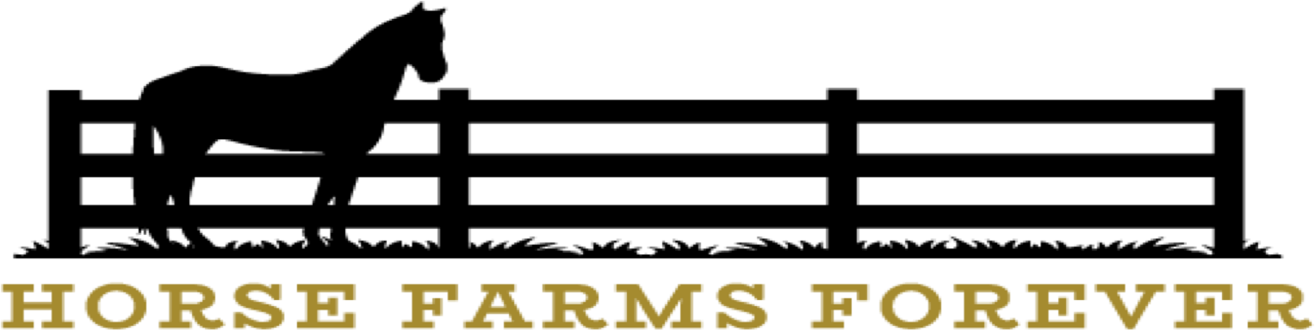**FOR IMMEDIATE RELEASE**

For additional information, contact:

Busy Shires, Dir. of Conservation Strategies

Horse Farms Forever, Inc.®

busy.shires@horsefarmsforever.com  
(386) 853-4437

**PRESS RELEASE**

**Mark Emery to be Keynote Speaker at Horse Farms Forever’s Conservation Summit**

**Ocala, FL – September 6, 2024** - Horse Farms Forever, Inc.® is pleased to announce Mark Emery, an Emmy award-winning filmmaker, musician, and photographer for National Geographic, the Smithsonian Network, BBC, and PBS as our Keynote Speaker at the **2024 Conservation Summit** to be held on Thursday, November 14 at the Ocala Breeders’ Sales Arena. The Title Sponsor is Brook Ledge Horse Transportation and Advent Health is the Presenting Sponsor.

## Mark’s stunning images and films of the springs will help create more awareness about how important Marion County’s springs are to ensuring clean drinking water for residents and visitors. We also welcome special guest speaker Margaret Ross Tolbert, internationally renowned artist of the springs and author of *AQUIFERious*. Also joining us is Dr. Emily Taylor, Ph.D., Executive Director of the Howard T. Odum Florida Springs Institute, a science and education based non-profit focused on restoring and protecting springs.

* Florida is home to more than 1,000 artesian springs that are dependent on groundwater from the Floridan Aquifer System.
* There are three **First Magnitude Springs** in Marion County and together, these springs discharge over 1 billion gallons of water per day: Silver Glen Springs, Rainbow Springs, and Silver Springs, which is the largest artesian spring in the world.
* The **Springs Protection Zones** for Rainbow Springs and Silver Springs are located within the 193,000-acre **Farmland Preservation Area**, which was designated in 2005 by Marion County to protect the rare agricultural soils and springsheds in the area.
* HFF is raising awareness about the importance of the Springs Protection Zones in the Farmland Preservation Area to help protect the recharge areas for the Floridan Aquifer. The aquifer is referred to as “the lifeblood of the springs” and is the source of much of Florida’s drinking water.

**Springs Forever Art Contest**  
To help nurture and encourage the next generation, Horse Farms Forever is sponsoring a poster and essay contest for all K-12 students in partnership with the **Marion County Soil and Water Conservation District.** The winners will be presented with ribbons and gift certificates at the Summit.

**Acorn Award Recipient**

Horse Farms Forever is honored to present the **Acorn Award** to **Guy Marwick**. Through his decades-long leadership, he has helped protect thousands of acres of environmentally sensitive land in Marion County and across Florida. Guy, who now serves as the Executive Director of The Felburn Foundation, was the original Founder and Director of the Silver River Museum & Environmental Education Center. The museum opened over 30 years ago in 1991 as a partnership with Marion County Public Schools and over 15,000 children visit the museum every year.

**LINKS:**

Mark Emery Films  
<https://markemeryfilms.com/>

Margaret Ross Tolbert’s Exhibit at the Appleton Museum of Art

<https://www.appletonmuseum.org/exhibitions/waters-margins/>

Florida Springs Institute  
<https://floridaspringsinstitute.org/>

Marion Soil and Water Conservation District

<https://www.marionswcdfl.gov>

Silver River Museum & Environmental Education Center

<https://silverrivermuseum.com>

**PRE-EVENT  
POSTER AND PRINT SIGNING at 4:00 PM**

**Mark Emery,** an award-winning filmmaker, musician, and photographer for National Geographic, the Smithsonian Network, BBC, and PBS will sign prints of his stunning photographs. **Margaret Ross Tolbert**, internationally renowned artist of the springs and author of *AQUIFERious*. will sign posters of her paintings. Prints and posters will be available for purchase at the event. The pre-event starts at 4:00 PM and will be held at the Ocala Breeders’ Sales Arena.

**MAIN EVENT**

**CONSERVATION SUMMIT: Springs Forever!**

**Date:**Thursday,November 14

**Time:**5:00 pm - 7:00 pm, light fare and beverages served (doors open at 4:00 pm)

**Venue:** Ocala Breeders’ Sales, 1701 SW 60th Avenue, Ocala, FL

**Tickets:** $45 each

**Event Information and Ticket Link:**

<https://www.horsefarmsforever.com/event/conservation-summit-2024/>